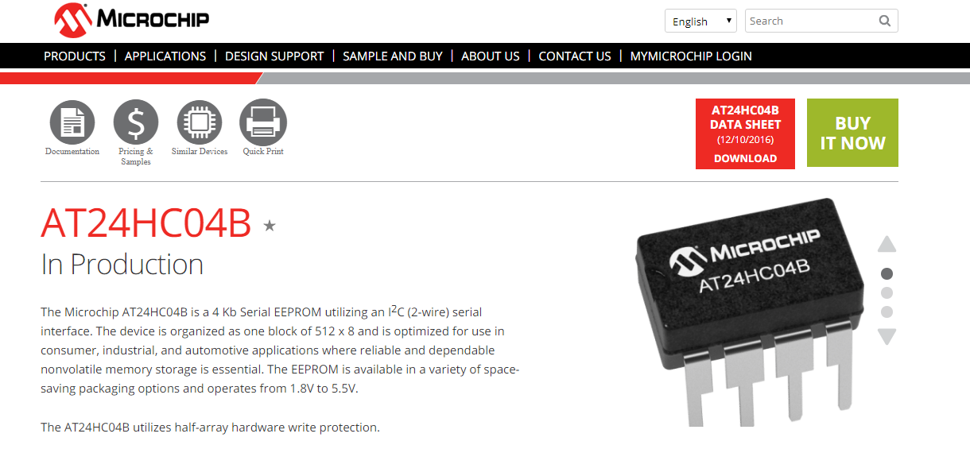

<https://www.microchip.com/wwwproducts/en/AT24HC04B>

Using AT24HC04B EEprom in Linux IMX

Linux kernel – already configured Y

AT24 is already configure Y in the kernel

I2C char device is already configure Y in the kernel

The source of the driver said:

**AT24.c - handle most I2C EEPROMs**

## From the Hw/Sw Doc:

## Configuration EEPROM memory

The configuration EEPROM memory contains card configuration information such as card MAC address, Assembly options such as CPLD assembled or not, Manufacturing information such as card serial no. manufacture date etc. The Configuration memory access via I2C #4, base I2C address is 52h. The memory is Microchip AT24HC04B 4Kbit EEPROM memory.

eeprom: eeprom@52 {

compatible = "at,24c512";

reg = <0x52>;

};

So reg is 0x52 – the I2c address.

# Compatible:

The driver at24.c supports many ids – size:

static const struct i2c_device_id at24_ids[] = {

/* needs 8 addresses as A0-A2 are ignored */

{ "24c00", AT24_DEVICE_MAGIC(128 / 8, AT24_FLAG_TAKE8ADDR) },

/* old variants can't be handled with this generic entry! */

{ "24c01", AT24_DEVICE_MAGIC(1024 / 8, 0) },

{ "24c02", AT24_DEVICE_MAGIC(2048 / 8, 0) },

/* spd is a 24c02 in memory DIMMs */

{ "spd", AT24_DEVICE_MAGIC(2048 / 8,

AT24_FLAG_READONLY | AT24_FLAG_IRUGO) },

{ "24c04", AT24_DEVICE_MAGIC(4096 / 8, 0) },

/* 24rf08 quirk is handled at i2c-core */

{ "24c08", AT24_DEVICE_MAGIC(8192 / 8, 0) },

{ "24c16", AT24_DEVICE_MAGIC(16384 / 8, 0) },

{ "24c32", AT24_DEVICE_MAGIC(32768 / 8, AT24_FLAG_ADDR16) },

{ "24c64", AT24_DEVICE_MAGIC(65536 / 8, AT24_FLAG_ADDR16) },

{ "24c128", AT24_DEVICE_MAGIC(131072 / 8, AT24_FLAG_ADDR16) },

**{ "24c256", AT24_DEVICE_MAGIC(262144 / 8, AT24_FLAG_ADDR16) },**

{ "24c512", AT24_DEVICE_MAGIC(524288 / 8, AT24_FLAG_ADDR16) },

{ "24c1024", AT24_DEVICE_MAGIC(1048576 / 8, AT24_FLAG_ADDR16) },

{ "at24", 0 },

{ /* END OF LIST */ }

};

MODULE_DEVICE_TABLE(i2c, at24_ids);

The device has 512x8



So we will select the compatible to at, 24c256

Final DTS change:

The eeprom is connected to i2c 4

&i2c4 {

clock-frequency = <100000>;

pinctrl-names = "default";

pinctrl-0 = <&pinctrl_i2c4>;

clocks = <&clks 116>;

status = "okay";

eeprom: eeprom@52 {

compatible = "at,24c512";

reg = <0x52>;

};

};

I added the eeprom to i2c

# [Reading and writing EEPROM via I2C with Linux](https://stackoverflow.com/questions/29932003/reading-and-writing-eeprom-via-i2c-with-linux)

<https://stackoverflow.com/questions/29932003/reading-and-writing-eeprom-via-i2c-with-linux>

<https://www.emcraft.com/som/stm32f7-212/accessing-i2c-devices>

Access through sysfs:

We need to try it out:

**echo -e "Some text\n" > /sys/bus/i2c/devices/0-0056/eeprom**  
**cat /sys/bus/i2c/devices/0-0056/eeprom**